ITT-216- Add Locations

Professor: Tim Collins
Course: ITT-216 Enterprise Route & Switch
Student: Liela Pressley
Date: 4/5/2023
Title: Benchmark-Host Hardening

Overview: After overviewing the configuration process, decided to configure a basic version of the added locations. Adding a mesh topology would have created more room for error in designating interconnection ports amongst the different routers. But I was able to successfully configure each LAN and their connectivity to the WAN as a whole as seen in the successful pings of each workstation within the added locations.
Location1Workstation Successfully Pinging Default Gateway(Switch) and NewLocation1 Router Interface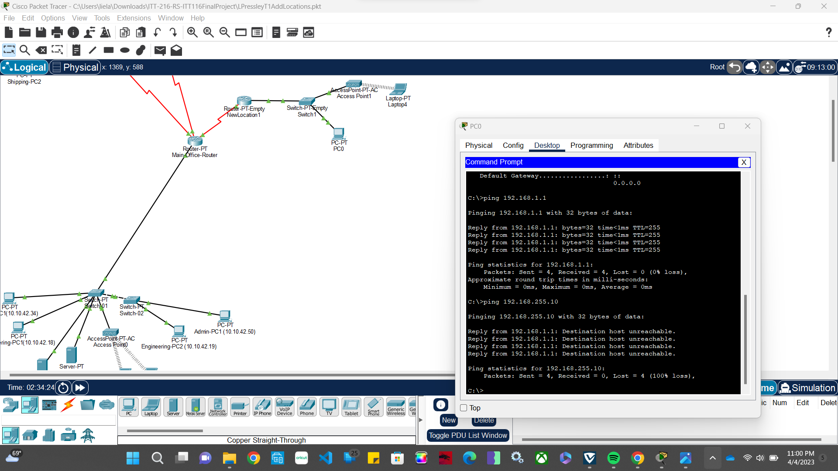

Successfully pinging Engineering workstation from PC0
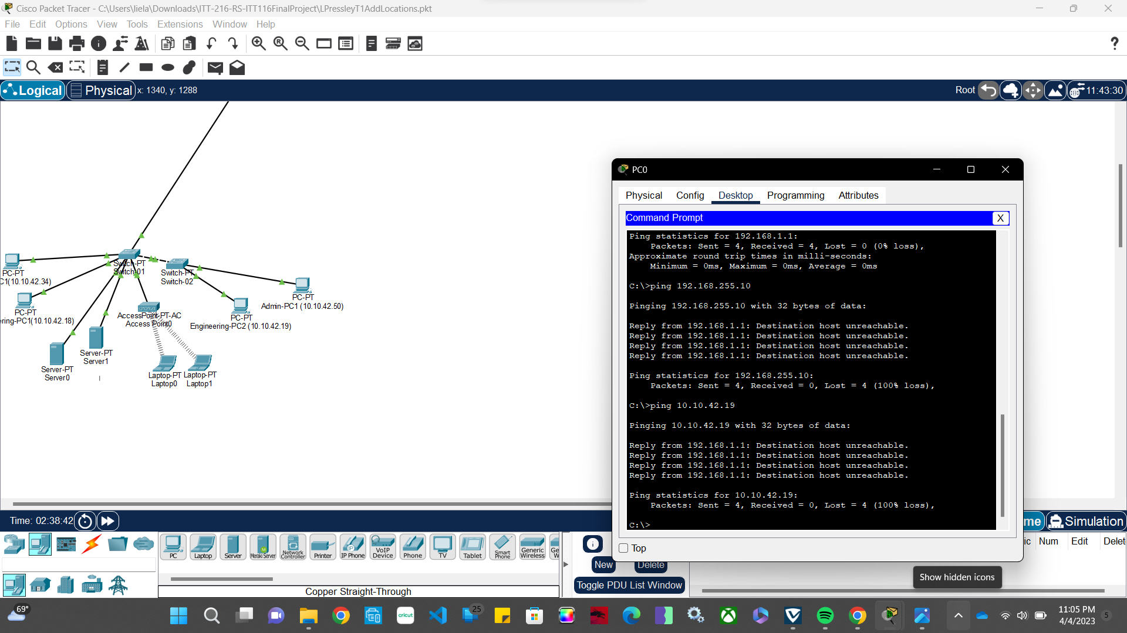
Location2Workstation successfully pinging its LAN router and Engineering PC2
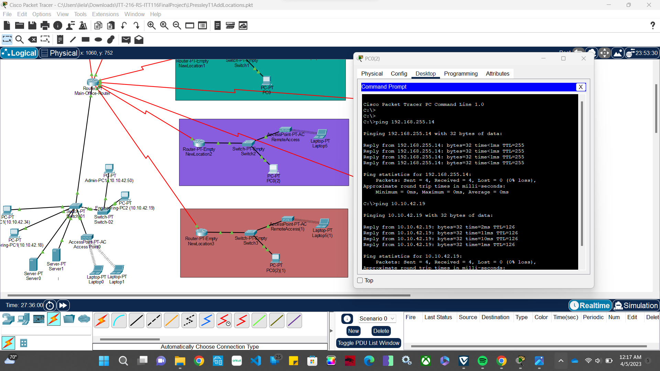

Location3Workstation Successfully ping LAN Router
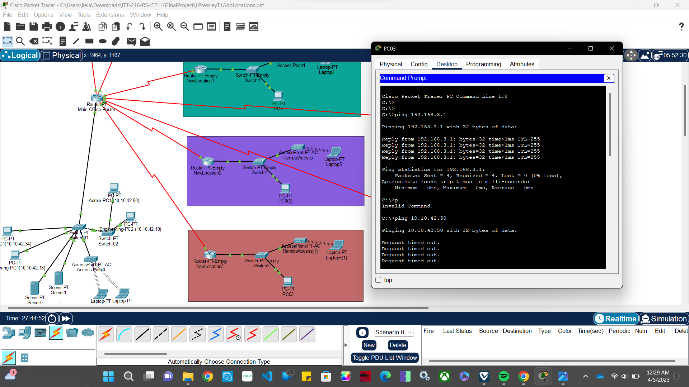

Location4Workstation Successfully ping its LAN router
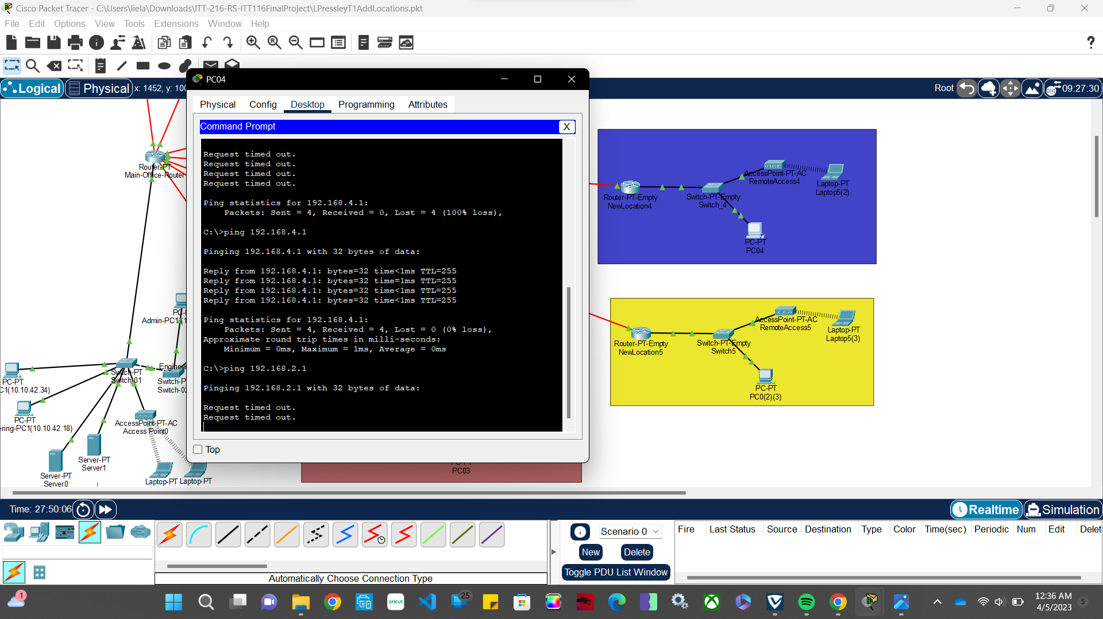

Location5Workstation Successfully ping LAN router via 2 different ports
